**Problem:-** The servlet component instantiation is happening through 0-param constructor, So programmers can not supply initialization data to servlet component class through constructor.

**Solution:-**This servlet config object is created just before invoking the init(-) life cycle method of servlet.The programmer can put his technical data(Database url, username,password,..etc) into servlet config object from web.xml file(as servlet **init param names and values**) . The servlet config object contains technical data is passed as argument to init(-) method.

The one servletConfig object is specific to per servlet comp class.

Example:-

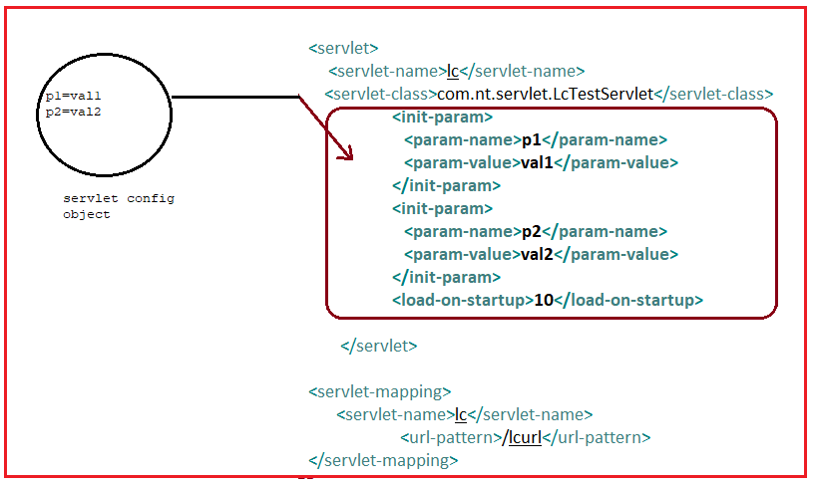

The servletConfig is interface. It have following methods.

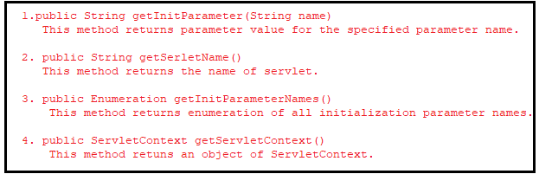

Note:- when we want to supply technical data to servlet comp class, It is better to use the ServletConfig object.

When we want to supply non-technical data to servlet comp class, It is better to use the ServletRequest object.

Non-technical is generated from “Form”.

Example:-

**ServletComponentClass: Demo.java**

**package** com.ser.domain;

**import** jakarta.servlet.ServletConfig;

**import** jakarta.servlet.ServletException;

**import** jakarta.servlet.annotation.WebServlet;

**import** jakarta.servlet.http.HttpServlet;

**public** **class** Demo **extends** HttpServlet {

**private** **static** **final** **long** ***serialVersionUID*** = 1L;

**public** **void** init(ServletConfig config) **throws** ServletException {

System.***out***.println("========Init Parameters=====");

System.***out***.println("ServletName:"+config.getServletName());

System.***out***.println("Salary:"+config.getInitParameter("salary"));

}

}

**Web.xml**

<?xml version=*"1.0"* encoding=*"UTF-8"*?>

<web-app xmlns:xsi=*"http://www.w3.org/2001/XMLSchema-instance"* xmlns=*"https://jakarta.ee/xml/ns/jakartaee"* xsi:schemaLocation=*"https://jakarta.ee/xml/ns/jakartaee https://jakarta.ee/xml/ns/jakartaee/web-app_6_0.xsd"* version=*"6.0"*>

<servlet>

<description></description>

<display-name>Demo</display-name>

<servlet-name>Demo</servlet-name>

<servlet-class>com.ser.domain.Demo</servlet-class>

<init-param>

<param-name>salary</param-name>

<param-value>7000</param-value>

</init-param>

</servlet>

<servlet-mapping>

<servlet-name>Demo</servlet-name>

<url-pattern>/Demo</url-pattern>

</servlet-mapping>

<display-name>s-Config</display-name>

</web-app>

**Output:-**



**When I sent first request for Servlet component class, we saw following output on server console.**

